1. **INTRODUCTION**

For power system analysis, load modelling is very important . A load model is a mathematical representation of real and reactive power changes due to the change of power system voltage and angle (frequency). Traditionally there are two types of load modelling, static and dynamic. There is a substantial component of load dynamics in the frequency range of system stability; hence, it is necessary to consider dynamic behavior of loads . Motors consume 60- 70% of the energy from the power system. Therefore, the dynamic characteristic of motors is critical for dynamic load modelling .

Many research papers have been published about load modelling [7-10]. The majority of those papers considered composite load model consisting of static and dynamic load, the dynamic load considered being an induction motor. Also many research papers have been published on the modelling of induction motors within load groups, [11-12]. In paper [12], the motor examined is loaded with position-dependent loads, while all other papers consider constant, speed variable or zero mechanical load. But none of the above mentioned papers considered induction motor with different kinds of shaft loads with variable power system parameters.

Induction motors are major loads in any power system therefore it is important to model induction motor with dynamic shaft loads accurately.

In this paper, two types of rotor speed dependent loads have been used; the linear load and the springy shaft with mass and fan load. In order to identify the model, Cross-Correlation identification method has been used with simple 1st order induction motor (which ignores the electrical transient). Cross-Correlation method is explained in section.1. MATLAB has been used to simulate the two types of motor models. MATLAB code ‘tfestimate’ is used to apply nonparametric identification process of Cross-Correlation to identify those models. And to validate the models using the algebraic equation of induction motors, as outlined in section.4.

Each of the examined papers on load modelling [7-10], considers only the variation of the power system generation parameters (voltage and frequency). But the general case for the load model is that power system affects the load and load affects the power system measurement. So, new technique is developed here for load modelling to consider that the load affects the power system as well. This is described in section.3. In Section.5, this new theory is applied in MATLAB to explain the real data.

Transmission lines are subjected to operate at maximum loading to meet the increasing power demand and to obtain a maximum financial return on the investment of transmission lines. If the power system is operated near to maximum power capability of transmission lines without suitable margin, disturbances like faults or equipment outage can trigger voltage instability phenomenon, leading to voltage collapse. Voltage collapse causes detrimental effects in social dimensions and results into a huge financial loss. These are the reasons for major concerns in voltage stability of power system. The authorities responsible for the operation of power system, rely on various parameters to ensure that the system is in stable operation with a suitable margin for voltage stability. The accuracy of these parameters depends on the accuracy of mathematical models representing the dynamics of the power system. This includes the modeling of generators, transmission lines, loads and other devices connected to the power system. Detail modeling of generators and transmission lines are found in the literature for power system analysis. However, it is impractical to implement detail model of each and every load devices connected to the system. Thus, power system loads are modeled as aggregated loads. These load dynamics makes a significant impact on voltage stability [1]. Different load models are proposed to represent more accurate load dynamics. In this thesis, the impacts of various load models are analyzed for static and dynamic voltage stability assessment of power system.

**1.1 PROBLEMS STATEMENT :**

As mentioned earlier large induction motor loads generally affect the voltage recovery process after voltage sag has been incepted due to system faults, and in many occasions due to extended voltage sag secondary effects such as stalling or tripping of sensitive motors might happen leading to massive load disruption. So, it is very vital to represent large, small and trip induction motor loads in various combinations in the system, so that we capture the stalling phenomenon of induction motor load, the real and reactive power requirements in the stalled state, and the tripping caused by thermal protection.The induction motor load must be modeled such that it is sensitive to dynamic variations in voltage and frequency, and emulates the typical characteristic of consuming more power at increased speeds.

**1.2 MOTIVATION:**

Voltage instability occurs as the load tends to consume power beyond the amount that can be supplied by the combined generation and transmission system. As the power system cannot supply demanded reactive power to the load, the bus voltage starts to decrease which is the main cause of voltage instability. Unless any immediate corrective actions are taken to restore the system voltage, voltage instability forces the system into a cascading outage leading to voltage collapse. This voltage collapse causes blackouts in the system, which leads to huge financial loss and badly impacts social life.

**1.3 OBJECTIVE**

The main objective of this paper is to develop an induction motor model with different types of shaft loads in order to reflect the real (∆P) and reactive (∆Q) power changes due to the random changes of power system Voltage (∆V), frequency (∆f).A load model is a mathematical representation of real and reactive power changes due to the change of power system voltage and angle (frequency). Traditionally there are two types of load modelling, static and dynamic. There is a substantial component of load dynamics in the frequency range of system stability; hence, it is necessary to consider dynamic behaviour of loads. Motors consume 60-70% of the energy from the power system. Therefore, the dynamic characteristic of motors is critical for dynamic load modelling .The majority of those papers considered composite load model consisting of static and dynamic load, the dynamic load considered being an induction motor. Also many research papers have been published on the modelling of induction motors within load groups. In paper, the motor examined is loaded with position-dependant loads. Induction motors are major loads in any power system therefore it is important to model induction motor with dynamic shaft loads accurately.

1. **VOLTAGE STABILITY IN POWER SYSTEMS**

Voltages at all buses of a power system remain within acceptable limit at normal operating conditions. During disturbances, the system voltage fluctuates beyond the acceptable limit for normal operating conditions. If the system fails to restore the voltage after the disturbances, such situation is called voltage instability. As the system is subjected to voltage instability immediate corrective actions must be taken to restore the system voltage into a stable operating point. Otherwise, it forces the system into a cascading outage leading to voltage collapse.

**2.1 Voltage Stability Definition and Classification**

Voltage stability is the ability of power system to maintain steady voltages at all buses in the system at normal operating conditions and after being subjected to disturbances” [26]. Voltage stability mechanisms are described using static and dynamic phenomenon. The static voltage stability is ensured if the steady state operating voltage of the system buses are more than the corresponding bus voltage at the point of maximum load ability. At maximum load ability, the injection of the reactive power into the system increases the system voltage. In dynamic phenomenon, voltage stability is further classified as small disturbance and large disturbance voltage stability[27]. In small disturbance voltage stable system, voltage restores near to the pre-disturbance stable state after the system is subjected to small disturbances. The small disturbances are caused due to the small load change in the system, small variations of power generation in the system, etc. In the large disturbance voltage stable system, the system voltage reaches to a post-disturbance equilibrium state, after large disturbances. Large disturbances are caused due to various types of faults in the system, single or multiple contingencies or due to a large change in generations or loads. Furthermore, voltage stability can be observed as short-term voltage stability and longterm voltage stability. Short-term voltage instability is caused by fast-acting devices such as HVDC and dynamic loads such as motor loads [28]. To analyze short-term stability phenomenon, it is essential to formulate dynamic modeling of loads. This type of instability occurs in the range of a few seconds. Long-term voltage instabilities are caused due to slow acting devices such as tap changing transformers, generator field current limiters and thermostatically controlled loads. This type of instability occurs in the range of a few minutes to several minutes.

**2.2 Voltage Stability Analysis in Power System**

Voltage stability is a dynamic phenomenon which includes the dynamics of devices connected to a power system. Voltage stability analysis is required for long term and short term planning of transmission lines and operation and control of power systems. The transmission planning engineers should know the maximum capability of a power system with or without contingencies. The power system operator should be aware of the operating condition of a power system at any time which includes the voltage level of all the buses and proximity to voltage instability. Furthermore, the details of a voltage instability mechanism including its cause and effects are to be known to prevent the voltage instability. This information is obtained through voltage stability analysis. Voltage stability analysis can be split into static analysis and dynamic analysis.

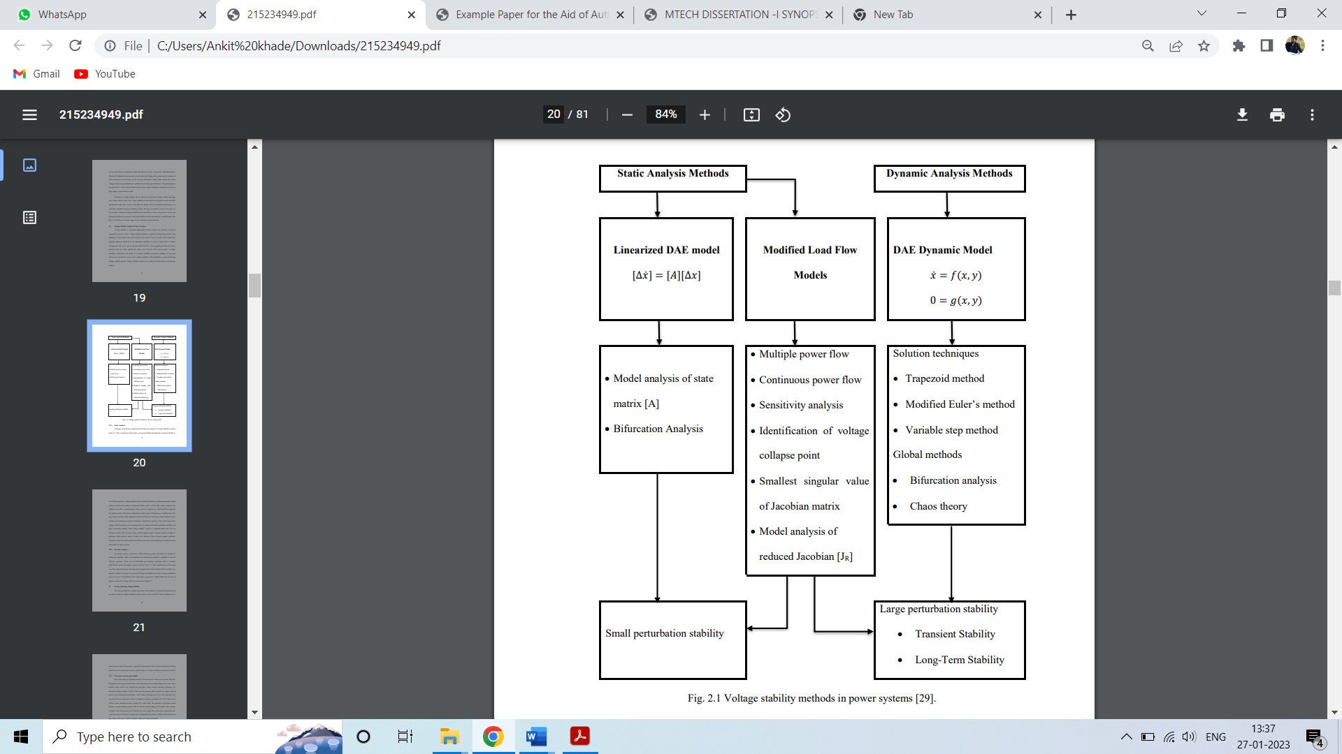

**2.3 Static Analysis**

A number of methods are implemented for the static analysis of voltage stability as shown in Fig. 2.1. These methods are based either on linearized differential-algebraic equations (DAE) or 10 on load flow equations. Voltage stability after the small perturbation is obtained through the modal analysis or bifurcation analysis of linearized DAE model. Various static analysis methods like multiple power flow, continuous power flow, sensitivity analysis, etc., utilize load flow equations for stability analysis [29]. The pre-disturbance stable system will maintain its stability only if the bus voltages reach the stable equilibrium after the disturbance. So the power flow equations can be utilized at pre-disturbance and post-disturbance equilibrium conditions. Power flow based static voltage stability methods can be implemented to determine both small perturbation stability and large perturbation stability. Static voltage stability analysis is computationally faster than the dynamic analysis. This is because static stability analysis requires only the solution of algebraic equations while dynamic analysis requires the solution of time domain dynamic equations. Therefore, the power system operators usually depend on the static methods for real-time operation and control of a power system.

**2.4 Dynamic Analysis**

In dynamic analysis, generators, AVRs, turbine-governors and loads are modeled in differential equations while the transmission and distribution network is modeled in terms of algebraic equations. These sets of differential and algebraic equations make a complete mathematical model for dynamic analysis as shown in Fig. 2.1. These equations are solved using one of the numerical solution techniques such as trapezoidal method, modified Euler’s method, etc. Dynamic analysis is required for transient and long-term stability when there is large perturbation such as the loss of transmission lines, large loads or generators. Details about the necessity of dynamic analysis for voltage stability is discussed in Chapter V.

**2.5 Factors Affecting Voltage Stability**

The voltage instability is mainly caused due to the inability of combined transmission and generation system to supply demanded reactive power to the load [26]. This can happen due to 11 reactive power limits of generators, congestion in transmission lines or due to the dynamic of loads and other devices connected to a power system. Causes of voltage instability are

discussed in detail.

**2.6 Generator reactive power limits**

Generators supply a significant amount of reactive power in the power system. When the demanded reactive power of the loads exceeds that produced by compensating devices, the excess reactive power needs to be supplied by generators. Under normal operating conditions, the automatic voltage regulator (AVR) of the generators increase their excitation to supply required reactive power demand and maintains a fixed voltage at the generator buses. The maximum limit of generator active and reactive power is guided by its power capability curve [30]. Then, as the reactive power demand increases beyond the certain limit, the generator’s excitation current becomes constant and the generator fails to maintain a fixed voltage at its terminal. This scenario is similar to that the generator act as PQ bus [31]. As a result, the reactive power generated in the system becomes less than the reactive power demanded by the loads, resulting in the decrease in the voltage of the buses, which eventually results into voltage instability

**2.7 Reactive Power Compensating Devices**

The use of compensating devices has a great advantage in a transmission system. Injection of the reactive power by these devices significantly increases the maximum power capability of the transmission lines and reduces system losses. These compensating devices can also be used as immediate corrective actions to supply demanded reactive power to the load. The capacitor bank is commonly used for shunt compensation as it is inexpensive than other compensating devices. The major disadvantage of this technique is that shunt capacitor generated reactive power depends on the square of the voltage of connected bus. During the voltage instability, with the decrease in bus voltage the reactive power generated by the shunt capacitor decreases [4]. Also, the switching of the capacitor is not very fast. As a result, a capacitor bank cannot maintain good reactive power support during low voltage conditions. To overcome this problem fast switching modern static 12 reactive power compensating devices are used in the weak buses. Under normal operating conditions, reactive power compensating devices support voltage stability phenomenon. However, due to the use of compensating devices, the transmission network is forced to operate near to maximum capability limit. Therefore, during faulted conditions or during contingencies the system is more prone to voltage instability.

**2.8 Load Modeling**

Various techniques to determine the voltage stability indices depends on the load modeling [7]. Thus, the accuracy of the results obtained from these techniques depends on the accuracy of load modeling. Different static and dynamic load models proposed by several researchers are presented in [13]. The load models used in power systems can be broadly classified into static and dynamic load models. Both types of load models play a significant role in voltage stability. If the system is connected to constant impedance load there will be no stability issue due to loads. The power consumed by constant impedance type of load decreases with the system voltage. The static load that mostly affects voltage stability is a constant power type of load. In this type of load, the total power consumed by the load is constant irrespective of fluctuation in bus voltage. When the voltage of the system decreases due to contingency or fault, the constant power loads draw more current. This additional current drawn from the system increases the system losses and voltage drop in the transmission system, which further decreases the bus voltage. Therefore, this type of static load supports the voltage instability phenomenon[32]. Induction motor loads act as dynamic loads in the power system. A step decrease in the bus voltage causes momentary step reduction in the power. This is followed by the load recovery phenomenon [16]. Reduction of power relieves the stress on the bus-bar for certain time but due to the recovery phenomenon the induction motor behaves as a constant power load and demands more current from the system, forcing the system into the condition of voltage instability. This acts as a fast dynamic load. Thus this type of load also supports the voltage instability phenomenon. Thermostatic controlled resistance loads are usually used for room heating or space heating purposes. These loads are designed such that it maintains a desired fixed temperature. When the bus voltage decreases, heat generated by the resistive load decreases. So, to maintain constant temperature the on-time of thermostatic load increases. Thus, for long intervals of time, these loads act as exponential recovery load [16] to the system and assist voltage instability.

1. **THEORY FOR CROSS-CORRELATION IDENTIFICATION**

Estimating an impulse response from input-output measurements is a component of system identification [13].One path is to compute the impulse response of a filter from the Cross Correlation of its input and output signals.The system of Cross-Correlation based identification is presented in fig.1.The measured system variable could be voltage or frequency. Due to other loads the variations in the measurement may not be predictable from past measurements or load affects. This is represented as a white noise input W1. Similarly there is a component of load variation which represents the unpredictable changes in load power by customers turning switches ON and OFF. This white noise component is represented by W2.

W1 ref fig.1 added to the normal steady-state operation signal u(n) (u(n) is either steady-state voltage or steady state supply frequency) and the sum v(n) or *s* (*n*)  *W*1 (*n*)  *u*(*n*) forms the input to the identified system (induction motor with different kinds of shaft load). Consider induction motor an ideal linear system which doesn’t generate any internal noise, to the output y(n) of which a noise signal W2(n) is added. Assuming the noise generally independent of both W1(n) and y(n), models the noise which is internally generated by any real system.

{W1(n)} is connected to the first input of the correlator, the other input of which is supplied by the additive signal, P(n) = y(n) +W2(n) as measured at the output of the system and input of the correlator thus produces an estimate of the correlation function *Rw p*().

The internal linear block is described by the input –output convolution relationship

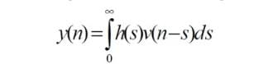

(1)

Where, h(s) is the impulse response of the induction motor with different kinds of shaft load.

If realized in discrete time domain, the Cross-Correlation function depends on the delay ξ as

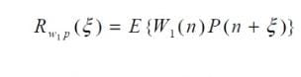

(2)

Substitute the value of P, in Equ. (2),

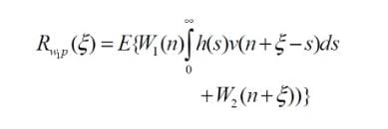

(3)

Expand the product in Equ. (3), and using the linearity of the mean-value operator which enables us to interchange it with the integrator operator, obtain

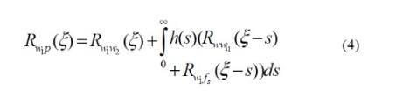

Based on assumption of independence of both the noise W2 (n) and the production signal f (n) on the auxiliary measurement signal W1 (n), the Cross-Correlation function *Rw1 w2* () and *Rw1 f* () are equal to zero and finally obtain,

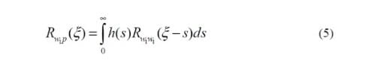

If Equ. (5) is transformed into frequency domain, the frequency response of the system can be determined as,

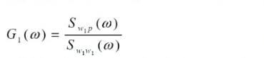

(6)

Which is given by the ratio of the cross and power spectrum and can be obtained by Fourier transform of the measured correlation function. Following the same procedure to get the transfer function between W1 and v,

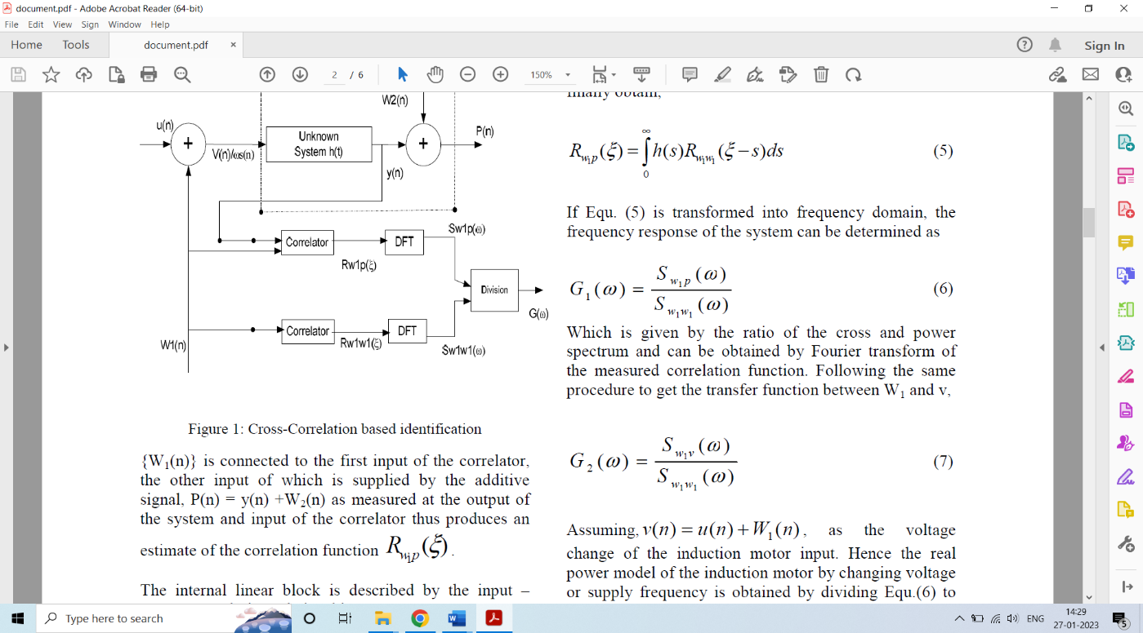

(7)

Assuming, as the voltage , *v*(*n*)  *u*(*n*)  *W1* (*n*) change of the induction motor input. Hence the real power model of the induction motor by changing voltage or supply frequency is obtained by dividing Equ.(6) to equ. (7),

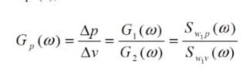

Similarly, reactive power model of induction motor by changing voltage or supply frequency is given by,

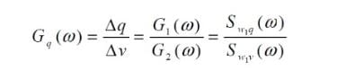

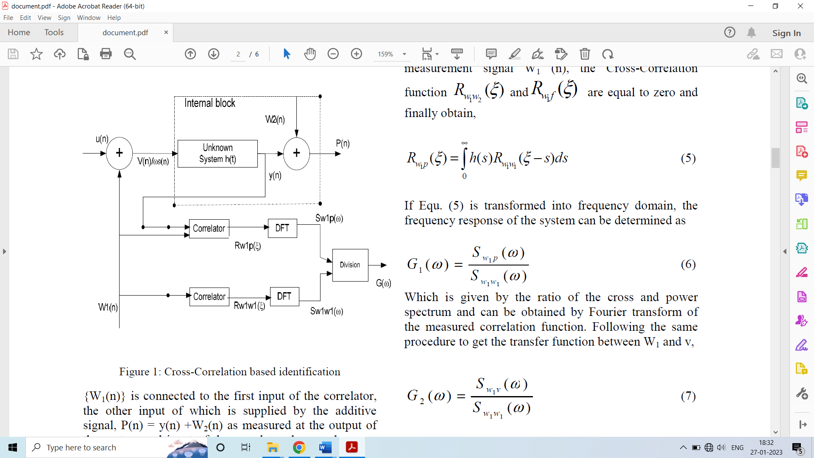

**4. THEORY FOR IDENTIFICATION OF A SYSTEM UNDER FEEDBACK WITH MULTIPLE NOISE**

The block diagram of the interaction between power system and load is shown in fig.2.W1 is the white noise of the power system and W2 is the white noise of load. These two indicates disturbance of the power system and load. The symbol X is the voltage or frequency (angle changes) in power system and Y is the real or reactive power of the load.

The more general case as shown in fig.2 can refer to cases where the power system affects the load and the load can affect the power measurement. When the load is significant for the power system strength, the feedback structures becomes important. In fig.2, if W2=0, the transfer function between X and Y would identify the feed forward system. If W1=0, the transfer function between Y and X would identify the feedback system. When both terms are present there is no clear separation between the effects. The idea behind this processing is to find out the best predictor for X and Y. The white noise component as the residuals for X and Y will thus be the white noise inputs W1 and W2. Thus the process can be to find the transfer function from W1 to both X and Y and the ratio will give the feed forward system A(s)/B(s), provided W1 and W2 are uncorrelated. Similarly we can find the transfer function from W2 to Y and X and the ratio will give the feedback system C(s)/D(s).

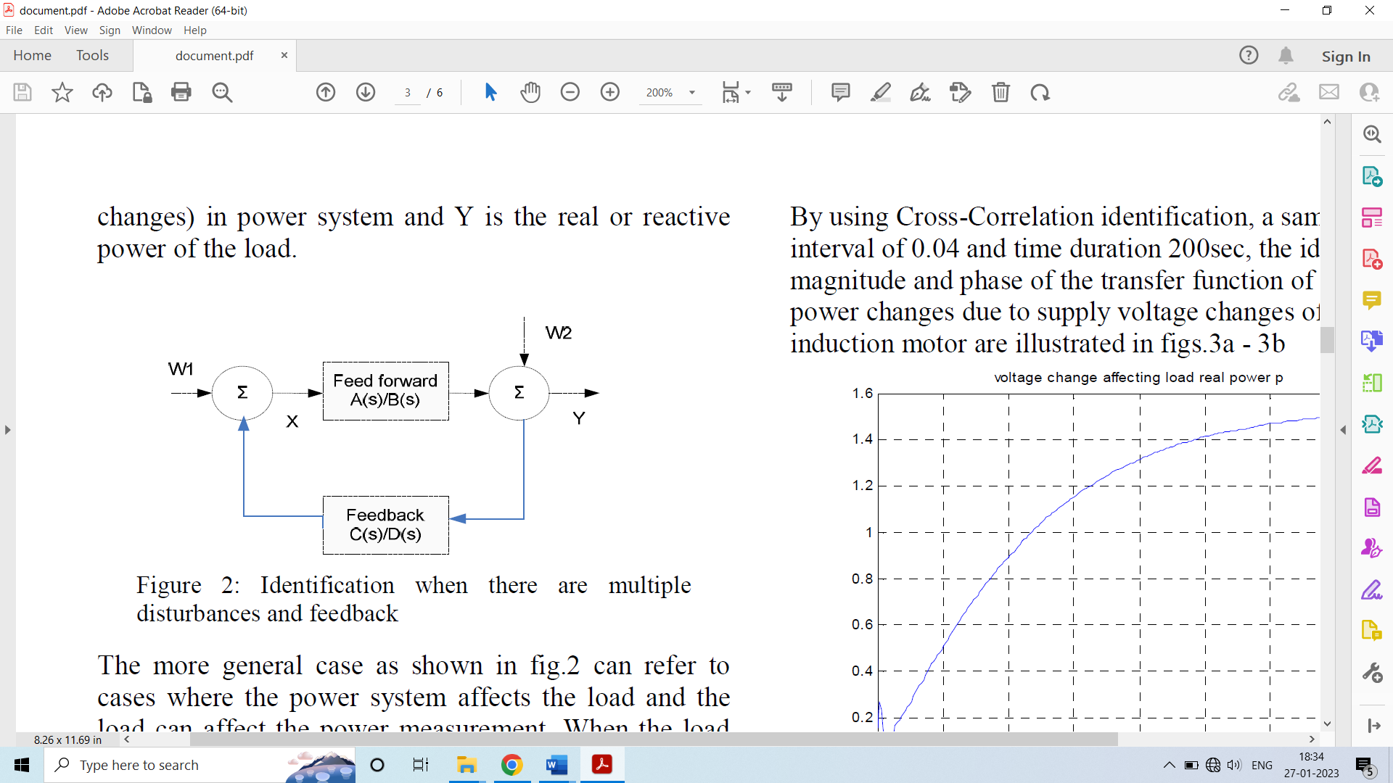

1. **SIMULATION**

A key component of load modelling has been developed to identify the induction motor model which has been simulated in MATLAB. Here the induction motor is examined with two different types of shaft load.

**5.1. INDUCTION MOTOR WITH LINEAR LOAD**

An induction motor with a linear load is simulated in MATLAB by using first order swing equation (ignoring the electrical transient). The equation is,

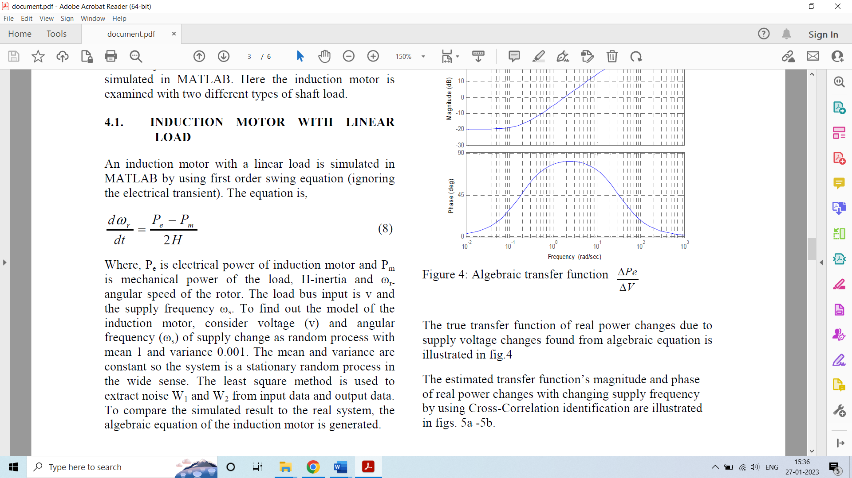

(8)

Where, Pe is electrical power of induction motor and Pm is mechanical power of the load, H-inertia and ω angular speed of the rotor. The load bus input is v and the supply frequency ωs. To find out the model of the induction motor, consider voltage (v) and angular frequency (ωs) of supply change as random process with mean 1 and variance 0.001. The mean and variance are constant so the system is a stationary random process in the wide sense. The least square method is used to extract noise W1 and W2 from input data and output data.To compare the simulated result to the real system, the algebraic equation of the induction motor is generated.

By using Cross-Correlation identification, a sampling interval of 0.04 and time duration 200sec, the identified magnitude and phase of the transfer function of real power changes due to supply voltage changes of an induction motor are illustrated in figs.3a - 3b.

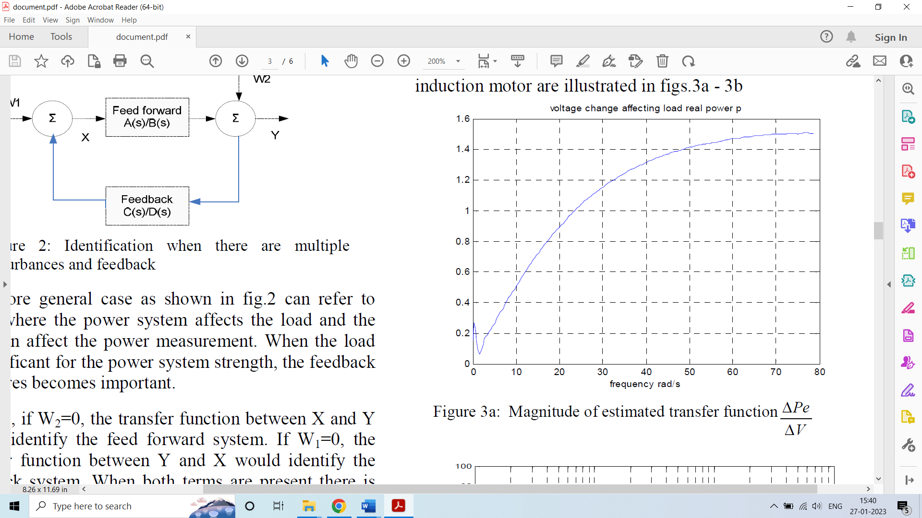

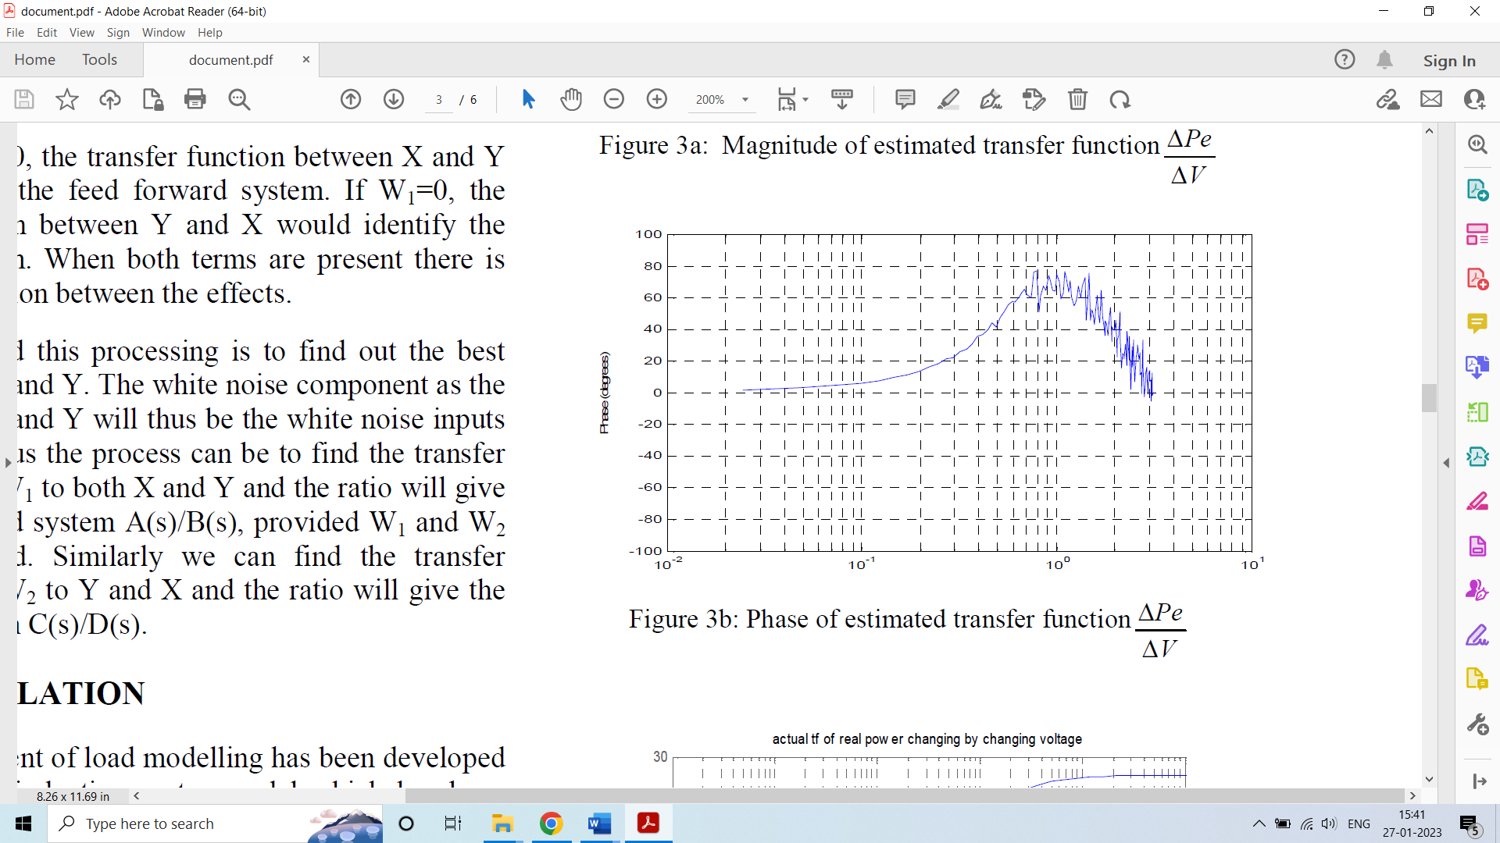

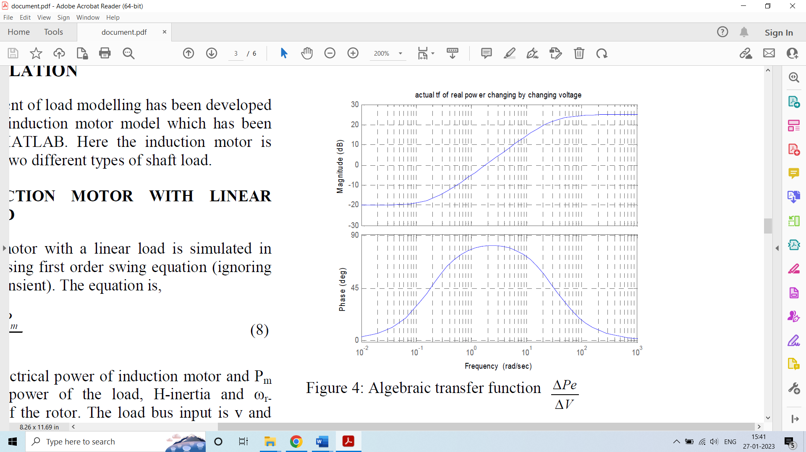

The true transfer function of real power changes due to supply voltage changes found from algebraic equation is illustrated in fig.4 The estimated transfer function’s magnitude and phase of real power changes with changing supply frequency by using Cross-Correlation identification are illustrated in figs. 5a -5b.

The actual real power transfer function by changing supply frequency is illustrated in fig.6

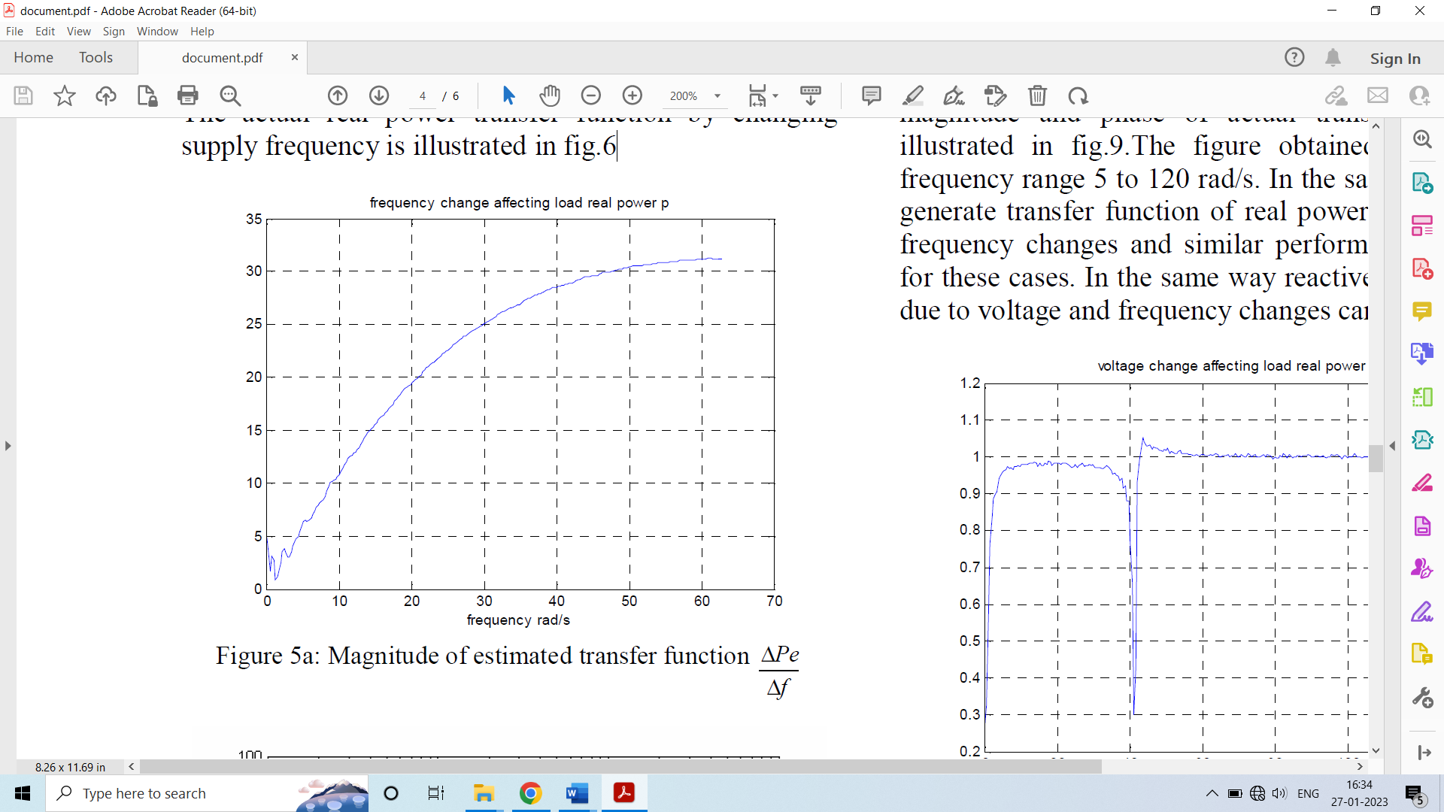

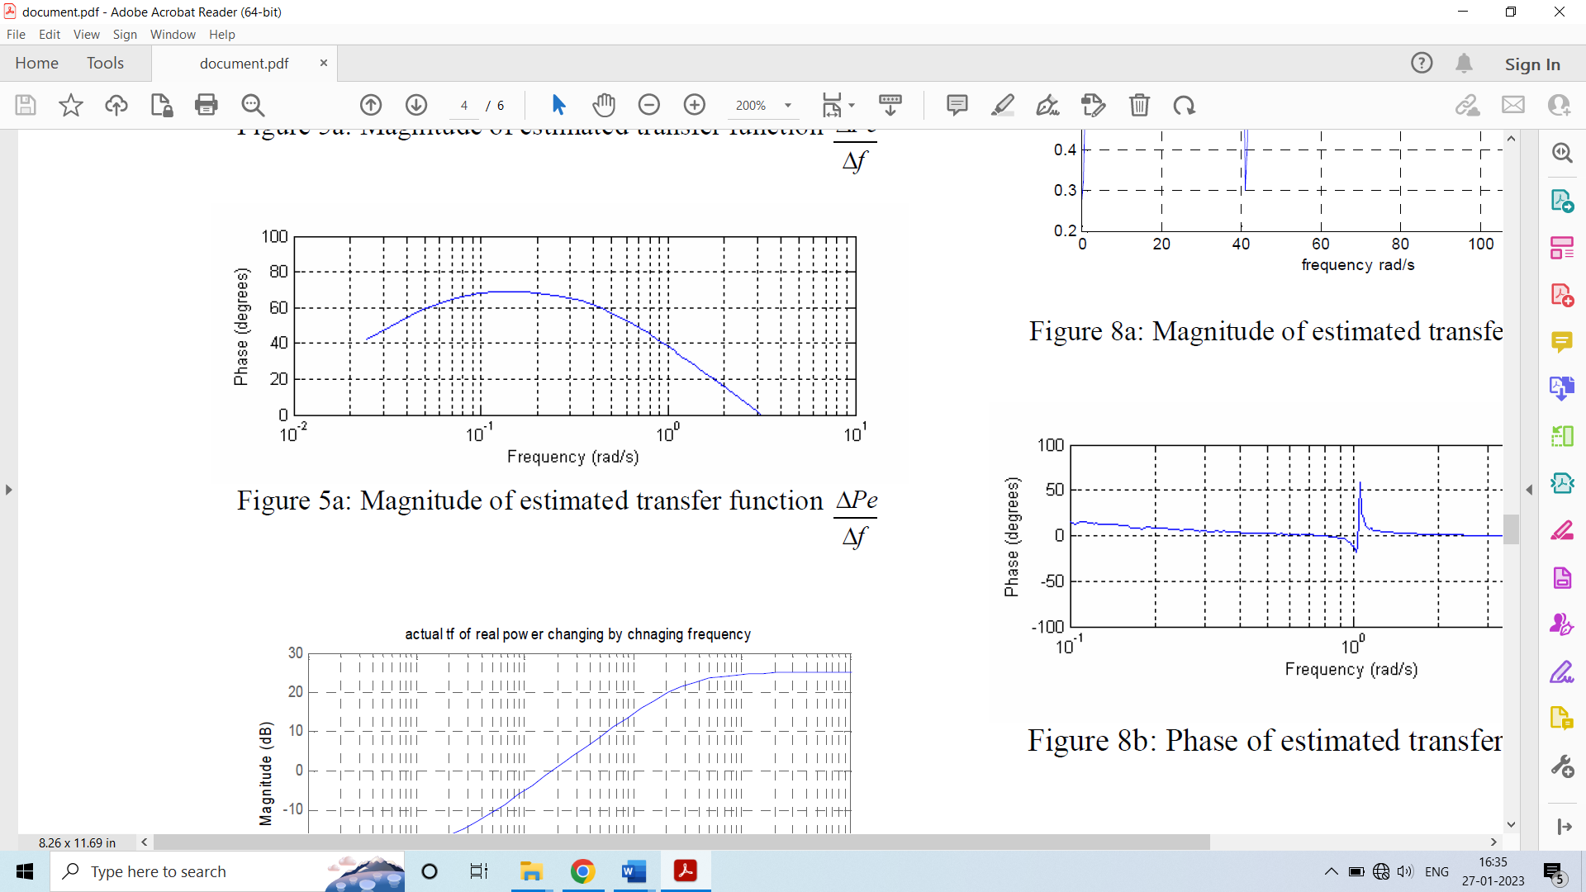

From the above figures we can conclude that the model estimated from Cross-Correlation follows the algebraic 1st order induction motor model from 10 to 60 rad/s.

**5.2. INDUCTION MOTOR WITH SPRINGY SHAFT LOAD**

Similarly induction motor with springy shaft fan load simulated by swing equations. Using Cross-Correlation identification, a sampling period of 0.025sec and time duration 250sec, the identified transfer function’s magnitude and phase of real and reactive power changes due to voltage changes of an induction motor with springy shaft load are illustrated in figs.8a - 8b. The magnitude and phase of actual transfer function is illustrated in fig.9.The figure obtained is good over frequency range 5 to 120 rad/s. In the same way, we can generate transfer function of real power changes due to frequency changes and similar performance was found for these cases. In the same way reactive power changes due to voltage and frequency changes can be found out.

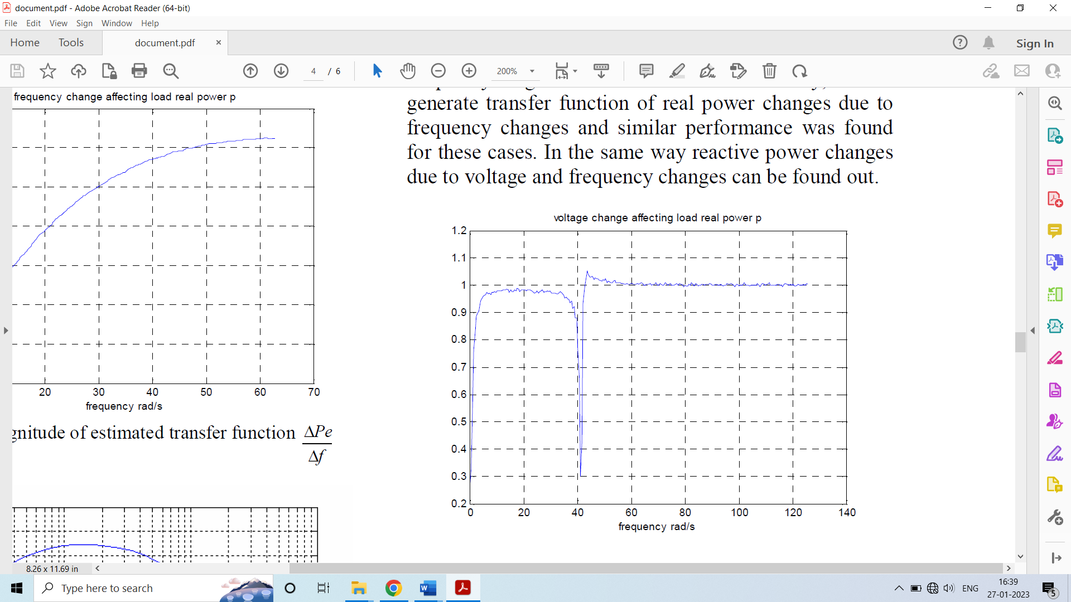

Figure 8a: Magnitude of estimated transfer function

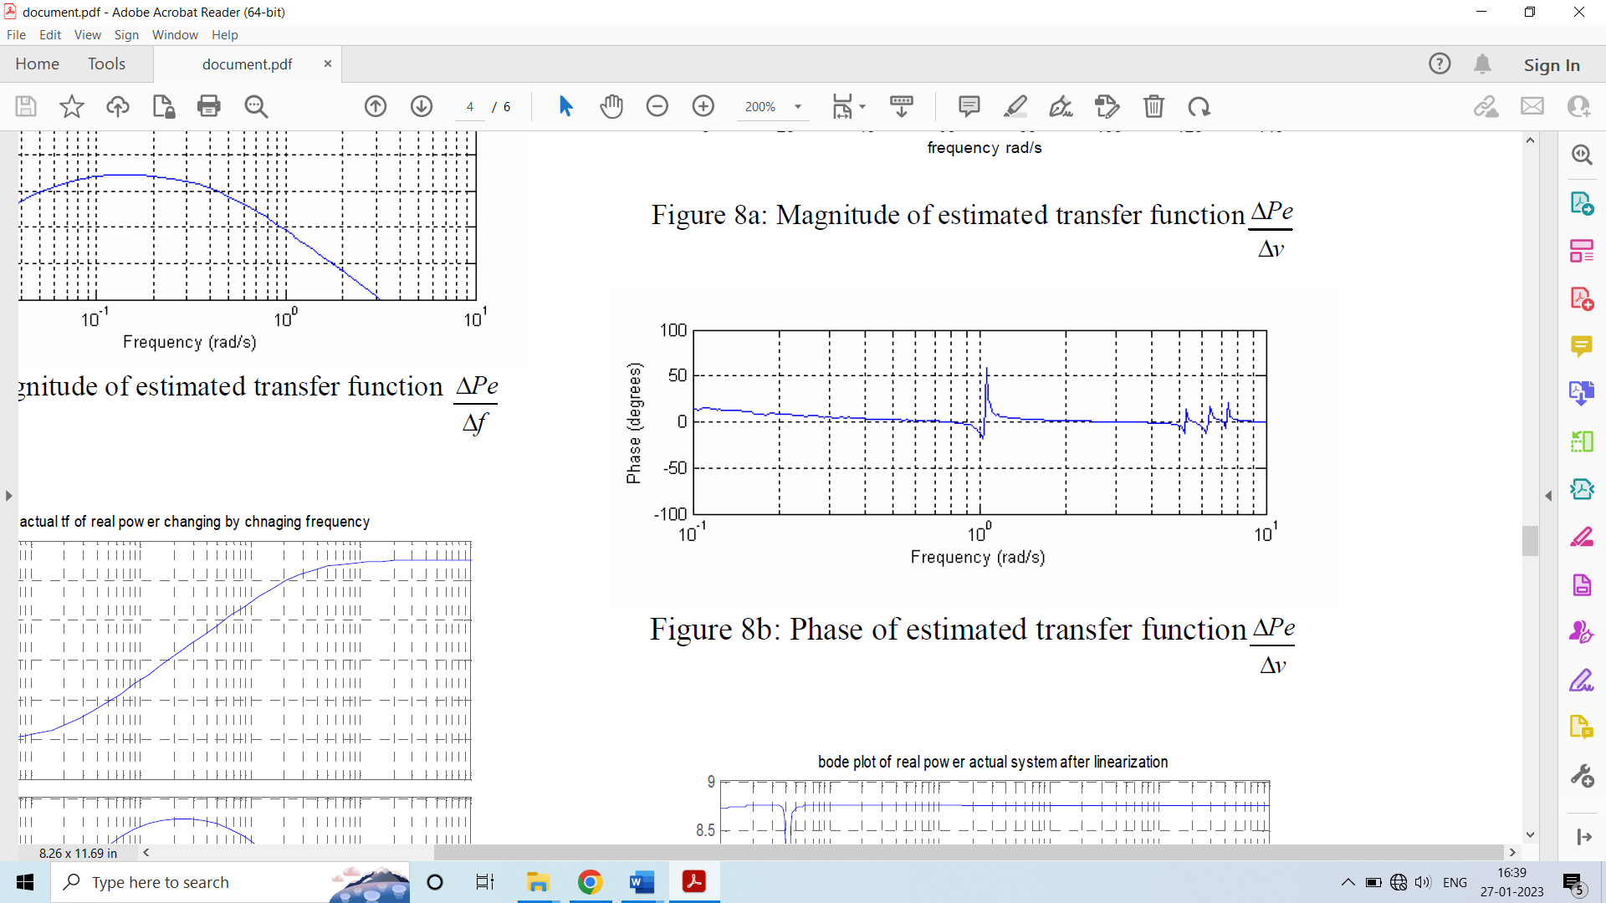

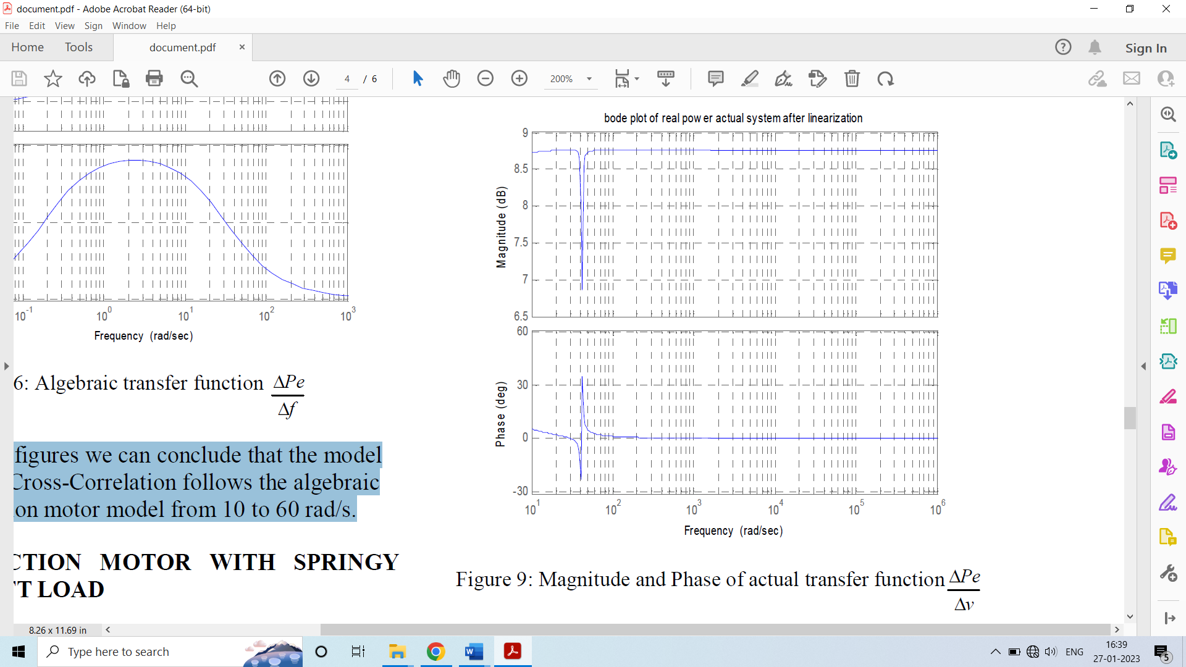

1. **CONFIRMATION OF THEORY BY USING REAL DATA**

To identify the load model, which is described in section.2, with multiple sources of noise Queensland University of Technology has installed a phase measurement device in South Pine substation to record system quantities such as bus voltage, feeder current and phase angle. On basis of the angle measurement, current and voltage data, frequency, real and reactive power can be obtained.

**6.1. FREQUENCY F –LOAD P MODEL:**

By applying theory outlined in section.2, the load model based on frequency f (as input X) and load P (as output Y) is created as shown in fig.2.W1 is the residual of f and W2 is the residual of load P. Based on this model transfer function A(s)/B(s) shows the frequency f changes affecting load P while Transfer function C(s)/D(s) shows load P changes affecting frequency f. The spectrum of the transfer functions are illustrated in figs.10 -11.

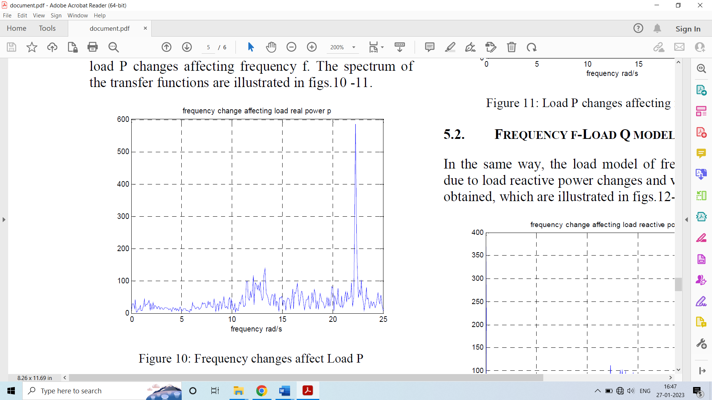

Composite loads abound in power systems. But the major frequency dependant loads are motors, especially induction motors, which have widespread use in industry. So frequency f to load (P) and load (Q) model needs to be explained in terms of the induction motor characteristic. We know the model to use with an induction motor with two different types of shaft load by changing frequency, described in section.4. fig.6 describes induction motor with linear load behaviour with changing frequency and fig.8a describes an induction motor with springy shaft behaviour. By using the induction motor behaviour as shown in fig.6 and in fig.8a we can explain fig.10. In fig.10, the frequency range 10- 15 rad/s affect an induction motor with linear load model while the frequency range 20-25 rad/ affect an induction motor of springy shaft load. In the 20-25 rad/s frequency range a huge peak is observed. It is not possible to explain that huge peak from fig.8a.In order to explain that peak we need to do further research. We need to know composite induction motor behaviour. The fig.11 illustrates load P changes affecting frequency. The spectrum of transfer function shows that it contains low frequency resonance. The most believable explanation is that the 20 sec period oscillation is associated with significant governor mode components. That means, load P changes from the major load give rise to much more response to system frequency at the governor mode than is seen at medium and high and high frequencies as in angle oscillations

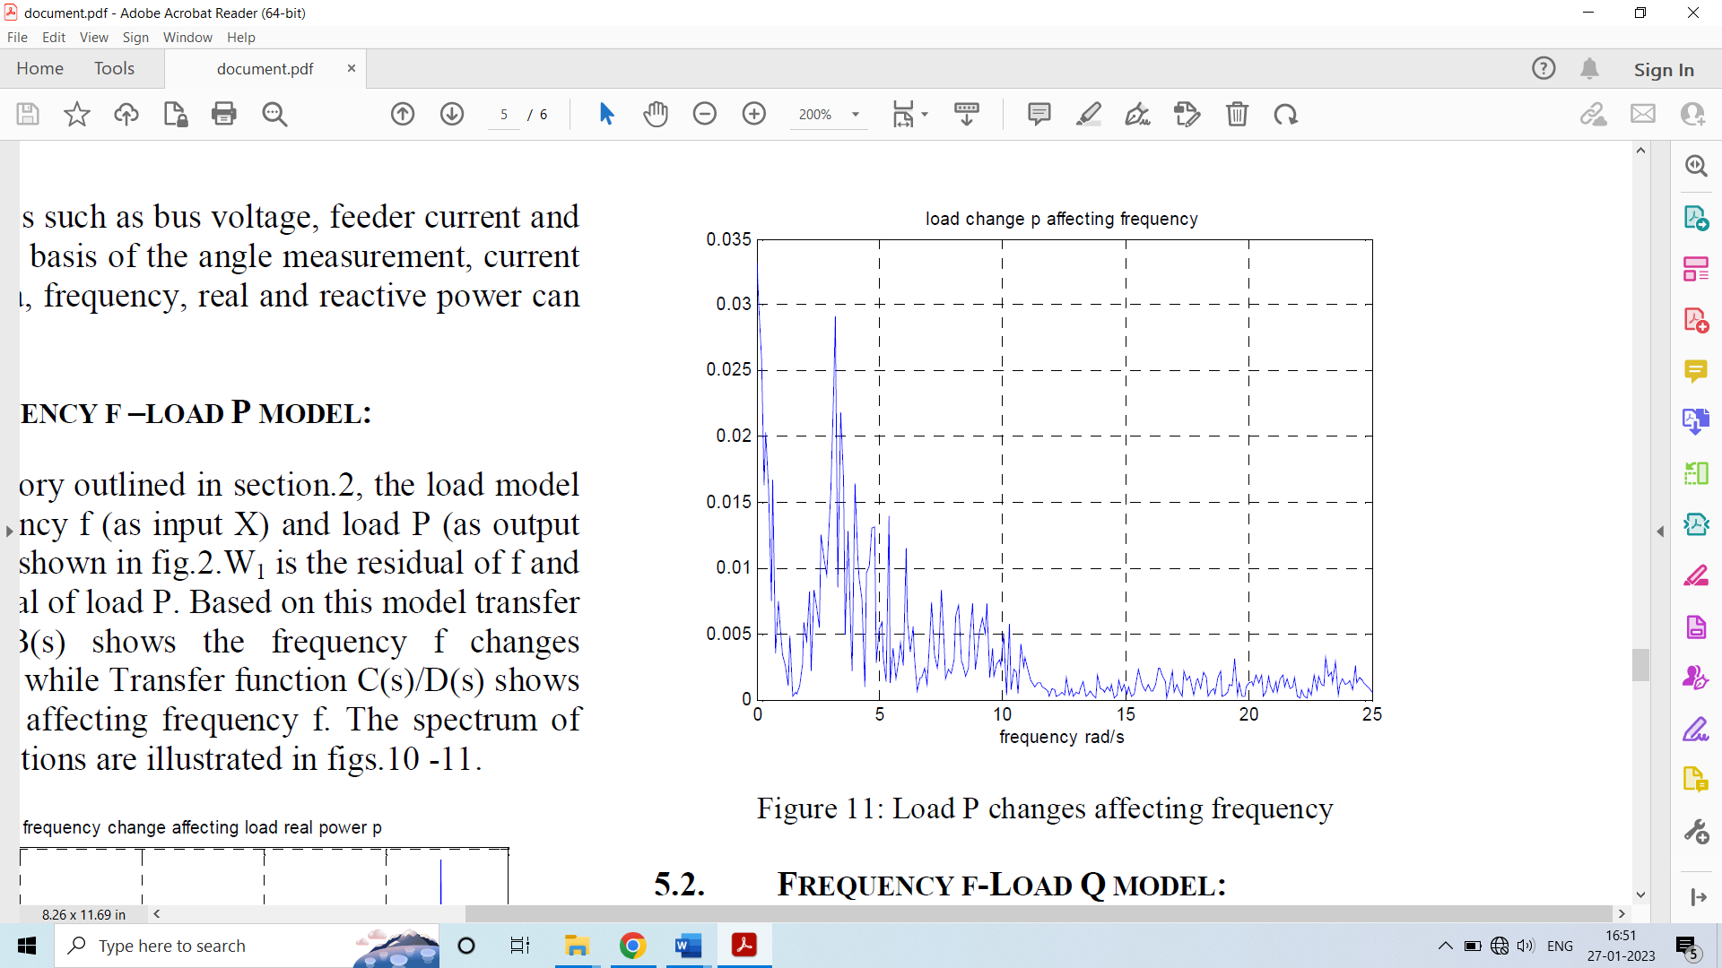

**6.2. FREQUENCY F-LOAD Q MODEL:**

In the same way, the load model of frequency changes due to load reactive power changes and vice versa can be obtained, which are illustrated in figs.12-13.

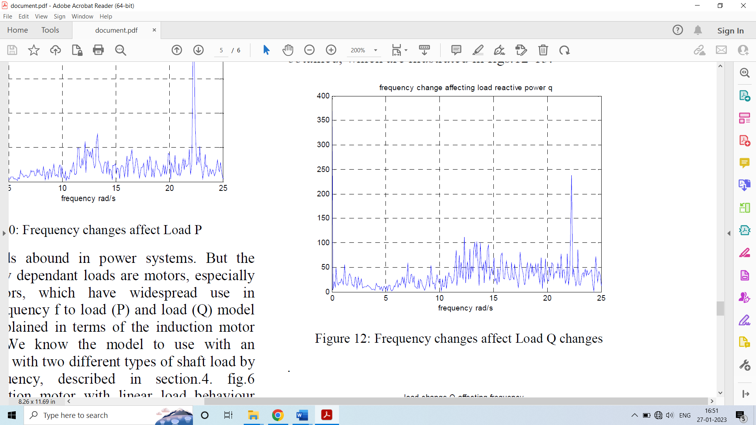

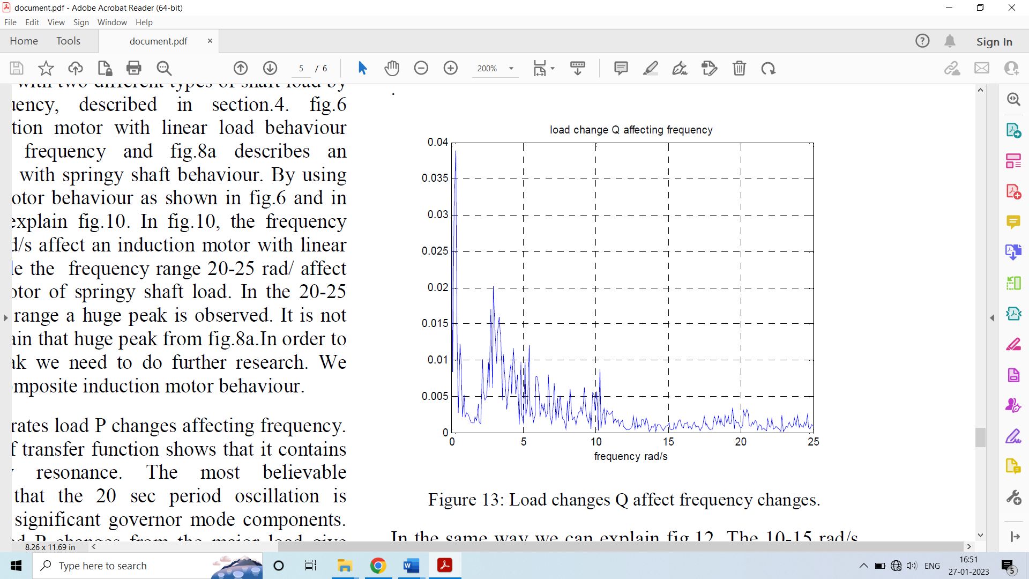

In the same way we can explain fig.12. The 10-15 rad/s frequency range best modelled by reactive power of an induction motor with linear load and the 20-25 rad/s frequency range best modelled by reactive power of an induction motor with springy shaft load. In fig.13 load Q changes affecting frequency. The spectrum of transfer function shows that it contains low frequency resonance. The most believable explanation is that the 20 sec period oscillation is associated with significant governor mode components. That means, load P changes from the major load give rise to much more response to system frequency at the governor mode than is seen at medium and high and high frequencies as in angle oscillations In this way, we can generate transfer function between voltage changes due to real and reactive power changes and real and reactive power changes due to voltage changes.

1. **DISCUSSION**

The Cross-Correlation identification which has been developed in this paper is theoretically correct. The model considered that there are no relations between W1 and W2 and between f(t) and W1. Actually, the relationships are not totally zero. So we can only suppose that these values are small enough in

comparison with the desired component and hence the influence will be negligible. Signal sequence length is also important for precision correlation analysis. So it is important to choose reasonably good length signal. In this problem the signal length is 10000 .In order to obtain the better estimate of Rw1p(ξ), divide the 10000 signal sequence into 8 windows, averaging them into 512 samples. The Cross–Correlation identification is applicable for discrete modelling of continuous time system when the upper limit of their working frequency band is lower than the nyquist frequency of the sampling that has been used. Therefore, sampling rate is important to achieve satisfactory result. We used MATLAB code ‘tfestimate’ to implement Cross-Correlation identification. But it is impossible to find out phase characteristic for that reason we used MATLAB ‘spa’ code to identify phase characteristic. Actually ‘tfestimate’ is based on periodogram for that reason we couldn’t find out phase characteristic. It is found that the estimation of system under feedback with multiple noise sources can give erroneous answer if the structure of the system is not carefully observed. Still there is a fundamental limit for frequencies. Where the signal level is poor, the quality of estimation reduces.

### CONCLUSION

We can conclude that by application of theory, developed in section.2, we can identify the relationship successfully which describes that load affects power system components (voltage/frequency) and power system components affect loads (real/reactive power) as well. Section.1 shows that Cross-Correlation identification method can estimate induction motor model. We can conclude that the model estimated from Cross-Correlation follows the algebraic 1st order induction motor model from 10 to 60 rad/s. And based on an induction motor model in section.1, we cannot explain the real data accurately. Since, there are many induction motors working in real world, it is not possible to explain the model from real data. For this reason, further research needs to be undertaken in order to model composite induction motor and analyses real data from the model.

### REFERENCES

1. IEEE task force on load representation for dynamic performance, “Standard Load Models For Power Flow and Dynamic Performance Simulation”, IEEE Trans. on Power Systems, Vol.10, No.3, pp.1302- 1313, Aug.1995.
2. Y.Liang,” Dynamic Reactive Load Model”, IEEE Transactions on Power Systems, pp.1365-1372, Nov.1998.
3. M.Bostanci, J.Koplowiz and C.W.Taylor, “Identification of Power System Load Dynamics Using Artificial Neural Networks”, IEEE Transaction on Power Systems, Vol.12, No.4, pp.1468-1473, Nov.1997.
4. I.T.F.OnLoad Representation for Dynamic Performance, “Load Representation for Dynamic Performance Analysis”, IEEE Trans syst., Vol.8, pp.472-482, May.1993.
5. P.Kundur,” Power System Stability And Control”, McGraw-Hill Book Co., Inc., New York, N.Y., 1994
6. I.A.Hiskens, “Significance of Load Modelling In Power System Dynamic”, University of Wisconsin- Madison, USA, x symposium of specialists in electric operational and expansion planning. May 21- 25, 2006.
7. C.W.Taylor, “Standard Load Models for Power Flow and Dynamic Performance Simulation”, IEEE Task Force for Dynamic Performance. IEEE Transactions on Power Systems, Vol.10, No.3, Aug. 1995.
8. F.T.Dai, J.V.Milanovic and V.Robert “Development of a Dynamic Power System Load Model”, EA Technology Ltd.UK, *Seventh* International Conference on AC and DC Transmission, London, UK*.* Nov 28-30, 2001.
9. C.J.Lin, Y.T.Chen and C.Y.Chiou, C.H.Huang “Dynamic Load Models in Power Systems Using the Measurement Approach”, IEEE Transaction on Power Systems, Vol.8, No.1, Feb.1993.
10. B.Khodabakhchian and G.Tong.,“Modelling a Mixed Residential – Commercial Load For Simulations Involving Large Disturbances”, IEEE Transaction on Power Systems, Vol.12, No.2, May.1997.
11. A.Bogdan, “Identification of Variable Frequency Induction Motor Models from Operating Data”, IEEE Transactions on Energy Conversion, Vol.17, No.1, Mar.2002.
12. E. Delaleau and A.M. Stankovic, “Modeling and Simulation of the Induction Motor with Position Dependent Load Torque”, Proceeding of the 42nd IEEE Conference on Decision and Control, Maui, Hawaii USA, Dec.2003.
13. J. Jan, “Digital signal Filtering, Analysis and Restoration”, IEE Telecommunication series. 2000